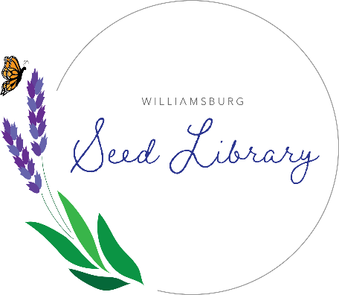
Williamsburg Seed Library FAQ

Mission Statement: The mission of the Williamsburg Seed Library is to provide everyone the opportunity to practice self-sufficiency, experiment with science, engage with the natural world, and connect with neighbors in a collaborative environment of lifelong learning.

What is a Seed Library?
A seed library is a collection of seeds, usually heirloom, which may be borrowed by members.

How are seeds borrowed?
When you choose heirloom seeds, you can save seeds at the end of the season to plant the next year. Our seed library will grow when gardeners learn to save seeds and donate them back to the collection.

Do I have to save seeds?
No, you don’t. Saving seeds is part of the fun, but is not for everyone and is not expected or required.

Seeds are cheap, why save seed?
Gardeners can maintain their own collection of unique varieties, return to a more traditional farming practice, help maintain genetic diversity in the food system, and save money.

Where is the seed library located?
The Williamsburg Seed Library is located within the Williamsburg Public Library. Specifically, the seed library may be found near the fireplace on the main level.

Where did the seed library get its seeds?
Our initial seed stock came from donations from Seed Savers Exchange, Bakers Creek, and multiple local gardeners.
Who can participate?
Anyone! Members do not need a library card to participate.

How do I check out seeds?
Simply select seeds from the collection and record them on the clipboard. We ask for a name, location, and how many packets you checked out so we have the statistics to tell our seed library’s story.

How many seeds can we take?
Each family may choose up to ten packets of seeds. If there are extra seeds, we will open it up again for members to take more, so be sure to sign up for the email list.

Will there be classes to help gardeners?
Yes! Stay tuned for more information.

Where can I get more info?
Call the library at (319) 668-1195 and ask for Shelley.

